8th Grade:

Expressions and Equations
System of Equations
Solving for x using distributive method with
fractions
Geometry
Transformations
Angles
Pythagorean Theorem
Distance between two points
Functions and Number system
Slope/rate of change/constant of proportionality
Linear? Not Linear?
Square roots
f(x)=2x+3 is the same as y=2x+3
rational and irrational
Misc
Volume of cylinders, spheres, cones
Positive and Negative exponents
Dividing with pos./neg exponents
Multiplying with exponents
Multiplying with Scientific Notation
Scatter Plots
Relative Frequency Table

7th Grade:

Expressions and Equations
Solving for x using distributive method with fractions
Solving for x with inequalities
Geometry
Angles
Complementary
Vertical angles
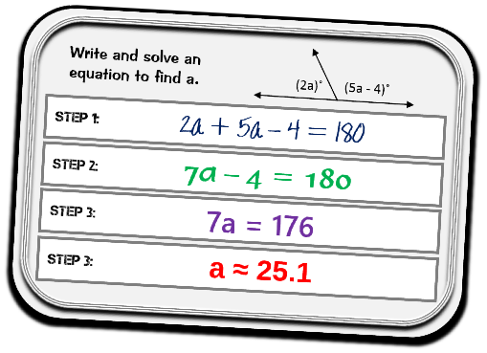
Perimeter
Area of circles/Circumference of circles
Area of rectangles/squares/triangles
Surface Area
Find the complement
Volume of a cube
Cutting a figure (playdough activity)
Isosceles triangle

Functions and Number system
Adding/Sub/Multi/Div./rational numbers
(pos.neg/fractions)
Absolute Value
Ratios and proportions
Misc
Probability
Likely, most likely, unlikely
Mean, median, mode
Dot Plots
Scale factor and proportions
Rate problems

